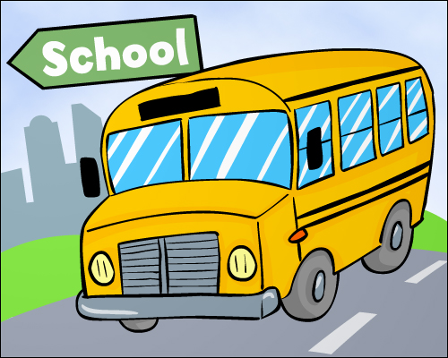

**Third Grade News**

**Mrs. Eiken’s Class**

**October 1, 2021**

|  |  |  |  |  |
| --- | --- | --- | --- | --- |
| **monday** | tuesday | wednesday | thursday | friday |
| **4**  **Flu shot clinic** | **5**  Picture Day | **6** | **7** | **8** |
| **11**  **No School for students – Staff PD day** | **12** | **13** | **14** | **15** |
| **18** | **19**  **PTO meeting 6pm in library** | **20**  **2 hour early release** | **21** | **22**  **End of 1st Quarter** |

**Social Studies/Science-** We will be finishing up our science unit on electricity and magnets and beginning learning about the government.

Don’t forget to be coloring book it charts every night your child reads at least 20 minutes – 5 times a week gets your child a personal pizza coupon.

This Tuesday, October 5th, is West Picture Day.

An interview is coming home today as part of our Patricia Polacco writing unit. Please help your child complete the interview this weekend and return on Monday. Thanks!

**October**

**At West Elementary School, we provide students with “I can” statements to set a purpose for our learning each day. Our learning goals for this week are…**

**Reading:**

*I can summarize the beginning, middle, and end of a story.

* I can summarize by sequencing the events of a text.

*I can follow effective listening rules.

**Math:**

*I can create an array to model multiplication and find factors.

* I can use the Commutative Property of Multiplication to compare two equivalent number sentences.

*I can use the properties of 0 and 1 in multiplication.

*I can multiply by 0, 1, 2, 4, 5, 10

WE ARE WORKING ON MULTIPLICATION FACTS - FLASH CARD PRACTICE AT HOME WOULD BE GREAT!

**Writer’s Workshop**:

* I can ask questions that stay on topic to check my understanding.

* I can link my comments to others.

PARENT TEACHER CONFERENCES ARE COMING UP in November. Be on the lookout for information.

*******************************************

**Specials**

**Monday: PE**

**Tuesday: Art**

**Wednesday: Music**

**Thursday: PE**

**Friday: Art**